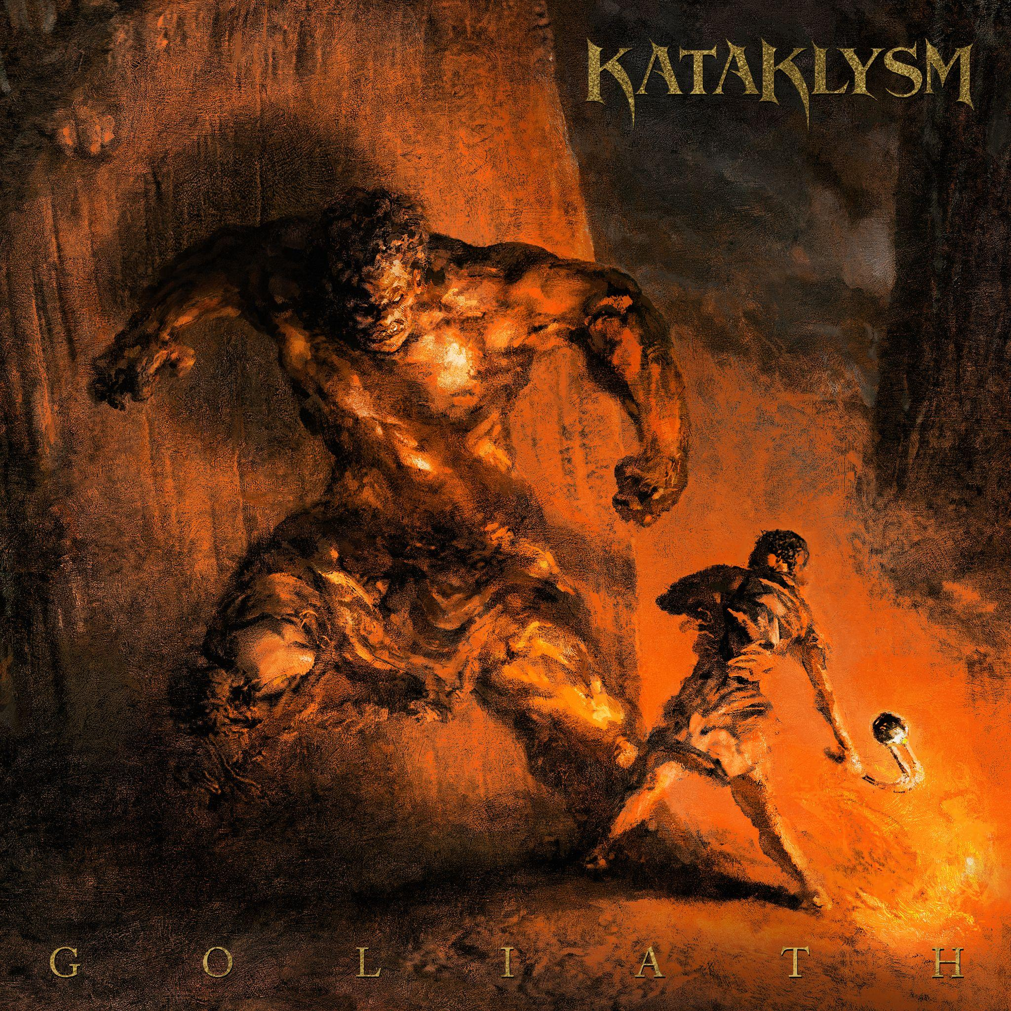
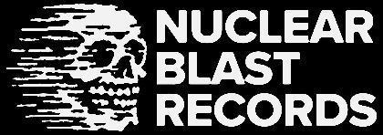

KATAKLYSM
GOLIATH

Release Date: August 11th, 2023

Line up: | KATAKLYSM online:
Maurizio Iacono | Vocals  JF Dagenais | Guitars  Stéphane Barbe | Bass  James Payne | Drums | www.kataklysm.ca  www.facebook.com/kataklysm  www.instagram.com/kataklysmband  www.twitter.com/kataklysmband
For almost 3 decades, the US/French-Canadian based melodic death metal syndicate KATAKLYSM has delivered unapologetic waves of powerful sound across the entire globe. On August 11th, the band’s 15th full-length studio album GOLIATH will be unleashed unto the masses via Nuclear Blast Records.

Following the release of 2020’s highly acclaimed Unconquered album, KATAKLYSM had more time than usual to work on the follow up album. Normally equipped with a release every two years, the band had the opportunity to really craft this album over the span of 3 years. GOLIATH, staying true to its name, is an aggressive and mean album that was a product of its own unique obstacles. "There’s a lot of anger but also a lot of darkness in this record, it reflects the current mood of the world” comments Maurizio Iacono. “GOLIATH is an album that searches deep into questioning things that are happening on a global scale and inside society itself, are you ok with everything you see?”

KATAKLYSM will deliver a one-two punch with the first and second singles that tell a concise story that is relatable to the current events happening worldwide. "Bringer Of Vengeance" opens with drop tune guitars and takes the listener on a journey mashing together modern Metal and Djent components that are layered over the traditional Kataklysm sound. The second single “Die As A King” is the prequel to “Bringer Of Vengeance” and is the modern update of traditional death metal meets catchiness. The 2-part story will be accompanied by music videos. Tracks like “Dark Wings Of Deception” offer the more traditional galloping guitars over thrash/punk style drums and with black metal undertones.

Maurizio goes on to say, “There's something weird going on around the world, there is a lot of dysfunction. And this record has this mean, aggressive feeling about it. It’s also about fighting back, Standing up even if it seems at times impossible to do so…a Modern day David vs Goliath : fighting back for what is right for yourself and the people you love. The record kinda has that type of overall reach.”

GOLIATH was recorded at JFD Studios in Dallas, TX and Studio City, CA as well as The Cabin in Orlando, FL by J-F Dagenais, who also produced and engineered the album. For the mixing and mastering, the band returned to Chris Clancy with assistance from Colin Richardson. The cover artwork required an image that captured the iconic battle of David versus Goliath theme that is echoed throughout the album while matching the power of the music. The band handed the reigns to renown Berlin metal illustrator Eliran Kantor (TESTAMENT, FLESHGOD APOCALYPSE) who took the KATAKLYSM look and gave it a macabre filter that compliments the brooding sense of uneasiness that was felt during the writing and recording of the album.

Not many bands have achieved what KATAKLYSM has in the span of their long and rigorous career, but what truly makes them stand them apart from the masses is seeing the world through truthful eyes, and creating the perfect musical landscape to describe it. With this new album, KATAKLYSM gives an innocent but aggressive album in a time of such uncertainty. Goliath is the band’s response to the kind of media that was being force-fed from both sides and coming up with their voice and identity that has made them the figures of Death Metal.

